More Than Sunday – Church Social Action Database

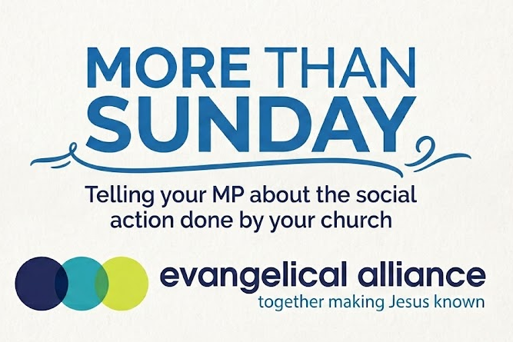

More Than Sunday – Let your MP know the church cares
So much of the good work happening in and through our churches goes unseen and unrecognised. Every week, churches across the country are feeding families, supporting young people, welcoming the lonely, helping people in crisis and bringing communities together. Yet too often, local MPs and decision-makers simply don’t know the full extent of what is happening on their doorstep.
This is an opportunity to change that. By completing this form, you can help your MP see the difference your church is already making in your community. Your story can help build a picture of the church as a vital part of local community life.
It only takes a few minutes, but it could open the door to a valuable relationship with your MP, create opportunities for partnership and help ensure that the contribution of churches is recognised when decisions about our communities are being made.
You are already making an impact. This is a simple way to make sure your MP knows about it.

Fill in your details:
Name:
Church name:
Denomination:
Role:
Email:
What does your church do for the community?

Tick all relevant:

Practical support
- Food bank
- Warm space
- Community meals / lunch clubs
- Clothing or baby bank
- Food deliveries to vulnerable people
- Debt advice
- Community café
- Support for carers
- Support for people with disabilities

Family and youth
- Parent / toddler group
- Youth club
- Holiday Bible clubs
- School visits
- Homework clubs
- Community sports clubs
- Football / sports outreach
- Parenting courses
- Marriage and relationship support
- Pregnancy / maternity support
- Foster and adoptive family support
- Arts, music or drama groups
- University student support

Wellbeing and community
- Visiting the elderly
- Befriending schemes
- Care home services / church services
- Mental health support groups
- Bereavement support
- Addiction support and recovery
- Hospital visiting / chaplaincy
- Community events
- Hosting community groups in our building
- CV and interview support

Vulnerable and marginalised people
- Homelessness outreach
- Support for asylum seekers / refugees
- English lessons
- Practical support for new migrants
- Prison visits / chaplaincy
- Support for ex-offenders / rehabilitation
- Domestic abuse support / referral
- Street pastors

Community and wider social action
- Partnerships with schools
- Partnerships with food banks and other charities
- Support for local charities
- Environmental work
- Community gardening / allotments
- Local litter-picking / clean-up projects
- Overseas mission / international development projects

OTHER

Personal Input Section
In your own words:
Tell your MP what they wish they knew about your church. This may be how your activities benefit the community, your growth, how the Lord is working in your church, and perhaps, how they could help. Your letter will be most effective with a genuine note of thanks for all the hard work your MP does as MPs rarely receive any praise for their work.
Need a starting point?

Examples:
- We’re seeing demand grow for… our food bank, which now supports more than 50 local families each month.
- We partner with the council on… providing a warm space during the winter, offering hot meals, company and practical support to people who might otherwise be isolated.
- A story that stuck with us this year… was an elderly neighbour who told us that our weekly lunch club was the first place they had spoken to anyone all week.
- You could support us by… helping us make connections with local schools and community organisations.
Permission boxes:
We need your permission:
- Add my church’s activities to a national database of church social action
- Allow the advocacy team to follow up

Template letter
Dear <title>,
Thank you for all the hard work you do serving our constituency and representing us in Parliament. We know that being an MP is demanding, and we are grateful for the time and energy you give to our local community.
I wanted to take the opportunity to share a little about our church and the contribution we are making in our local community. We are a church made up of people from across [area], and alongside our Sunday services, we regularly serve our community through:
- [Activity]
- [Activity]
- [Activity]
- [Activity]
[Add a short story, example or statistic that brings this work to life.]
We are passionate about seeing our community flourish and about being a good neighbour to those around us. We would love to find opportunities to work more closely with you and other local organisations where we can.
Our church is a member of the Evangelical Alliance, which represents churches and Christian organisations across the UK. The Evangelical Alliance would also value the opportunity to meet with you to hear more about your priorities for [constituency] and discuss how they can best support churches in our area. If you would be interested in meeting with them, please contact advocacy@eauk.org.
Thank you again for all that you do for our area. If there are ways in which you think we could work together, or if there are grants, funding opportunities or other support that could help us serve our community more effectively, we would be very pleased to hear from you.
And if there is ever anything we can do to support you in your work, please do get in touch. We would be delighted to help where we can.
With best wishes,
[Name]
[Role]
[Church name]
[Email]

For consideration
- The emails are sent from a single EA email address, but with the church leader’s email at the bottom. OR the church leader’s email address with EA cc’d in whichever is technically feasible.
- There is a filter to filter out bad language
- There is an up to date record of MPs to match with – MP contact spreadsheet?
- Build in MP visit ask as tickbox

- Cut down core activities and do an other box
- Church profile – statistics gatherer

More Than Sunday database content wording -
Let your MP know what your church is doing in your community.
Every week, churches across the UK are quietly making a difference — feeding families, supporting young people, tackling loneliness, helping people in crisis and bringing communities together. Much of this work goes unseen by the people making decisions about our communities.
More Than Sunday is a simple way to change that.
Tell us what your church is doing, share a story about the difference you are making, and we’ll help you turn it into a personalised introduction to your local MP.
By taking part, you’ll help your MP understand the contribution your church is already making, open the door to future opportunities to work together, and help the Evangelical Alliance build a national picture of the incredible social action happening through churches across the UK.

